CHEMISTRY 121/ENGLISH 151
URINALYSIS LAB PROJECT
After completing this lab project you will:
- Understand how urinalysis (urine analysis) is performed in medical labs.
- Understand how urinalysis aids in the diagnosis of various diseases/pathologies, list some of the diseases that can be diagnosed through urinalysis, and discuss the advantages and limitations of urinalysis as a diagnostic tool.
- Perform urinalysis using a chemical dipstick and report the results of urinalysis for a urine sample.
- Discuss advantages and disadvantages of the dipstick analysis.
- Analyze the results of the urinalysis for the urine sample assigned to your group and research to predict possible pathological conditions that would result in your assigned urine sample.
Pre-Lab Reading
- You will learn about urinalysis, among other things, during your visit to the medical lab. To complement this knowledge and prepare for the visit, read the following article:
http://www.labtestsonline.org/understanding/analytes/urinalysis/test.html. Make sure you click on the ‘chemical examination’ link (http://www.labtestsonline.org/understanding/analytes/urinalysis/ui_exams-2.html)
In the space below, summarize what you have learned in your reading regarding urinalysis in general; include the advantages and disadvantages of dipstick analysis:

- Additional information on the tests you’ll be performing can be found on the links listed below. After reading the information, summarize what you have learned about each test in the spaces below each link.
Protein in the urine - http://www.nlm.nih.gov/medlineplus/ency/article/003580.htm

Bilirubin in the urine - http://www.nlm.nih.gov/medlineplus/ency/article/003595.htm

Ketones in the urine - http://www.nlm.nih.gov/medlineplus/ency/article/003585.htm

Blood in the urine - http://www.nlm.nih.gov/medlineplus/ency/article/003138.htm

Glucose in the urine - http://www.nlm.nih.gov/medlineplus/ency/article/003581.htm

Specific gravity of urine - http://www.nlm.nih.gov/medlineplus/ency/article/003587.htm

Urine pH - http://www.nlm.nih.gov/medlineplus/ency/article/003583.htm

Nitrite in urine - related link - http://kidney.niddk.nih.gov/kudiseases/pubs/utiadult

These readings are the minimum amount of reading you should do. Feel free to expand your research by exploring these websites further, or finding additional articles to read (web-based or in printed journals). Make sure your information comes from peer-reviewed, credible sources.

The lab exercise
You will do part of this exercise individually and part as a group. A different urine sample will be assigned to each group and each member of the group will receive enough synthetic urine out of this common sample to carry out his or her own analysis. The members of the group will then compare their results and use the averages for the group for their analysis. Groups will be assigned in class according to common interests.
Procedure
- Collect a synthetic urine sample, a urinometer (unless otherwise directed), and a dipstick in the chemistry lab.
- Use the urinometer to determine the specific gravity of your urine sample. Fill glass cylinder with enough urine so that the urinometer will freely float and read the specific gravity on the urinometer. Alternatively we may use a dipstick with a specific gravity reading, if so, you will read it according to instructions in item 3 below.

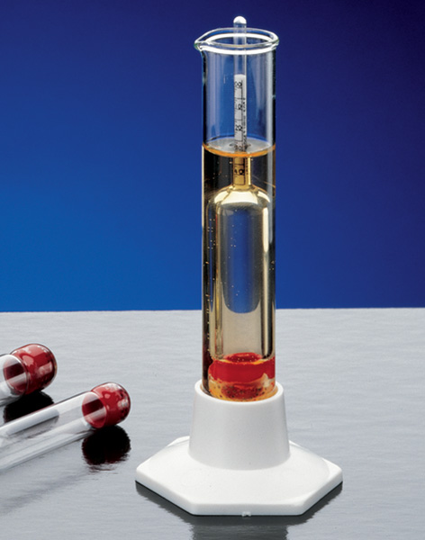

- Dip the stick in the urine sample (details will be added later) and compare to the readings on the container as shown below.

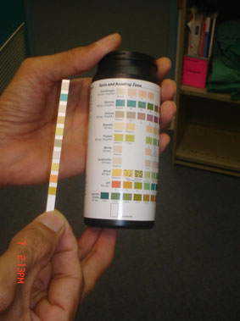

- Record your individual results in the data table in the column labeled Individual Result.
- Get together with the other members of your group and compare results. Your results should agree, since you all had portions of the same sample. If there is disagreement, repeat the measurements. Write the average values in the column labeled Group Result.

DATA TABLE
From your reading, determine what the values for each parameter should be for a normal urine sample (from a healthy individual). Write these ‘normal’ values in the second column labeled Normal Value. For some parameters there won’t be a numerical value, a concentration, or concentration range, the normal result may be ‘negative’.
.
Parameter Measured | Normal Value | Individual Result | Group Result
Specific Gravity
Leukocytes
Nitrite
pH
Protein
Glucose
Ketones
Urobilinogen
Bilirubin
Blood
Hemoglobin

Group Activity
As a group, you will research to find possible diseases that would produce a urine sample such as the one your group analyzed. In the space below, summarize the results of your group’s research.

